The role of marketing

Introduction
- Need to understand the consumer for your new product, this will inform product design, pricing decisions, promotional decisions etc.
  - Understanding of the consumer purchase process is required
- Product orientation – market may not yet exist, so you need to understand what the potential market would want
- Basic format of marketing is analysis and planning, then implementation
  - Analysis and planning: 3 Cs (company, customer, competitors
  - Implementation: 4 Ps (product, place, price, promotion)
- These steps can also be divided into market assessment then marketing programmes. This model is used to achieve the aims of marketing, which is to create, deliver and capture value to customers (firms) and consumers (individuals).

Bounded rationality
- Bounded rationality (Simon), the idea that humans have limit cognitive capacity thus do not make optimising decisions, fuels many behavioural biases which marketers can exploit
- Emphasis on quantitative analysis (regression and machine learning)

What is marketing?
- Advertising, sales, promotion, pricing, marketing research and analytics
- Most things can be marketed: goods, services, people, experiences, organisations, ideas

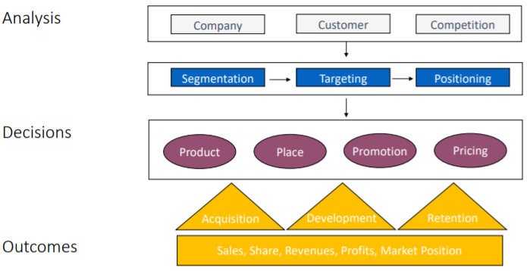
Marketing framework

Decisions: 4 Ps
- Product creates value (product design and branding in line with consumer tastes)
- Promotion communicates this value to purchasers (advertising, social, PR)
- Place delivers this value (distribution intensity and channels). Where do we sell – retail stores or online stores? Geographic location?
- Price captures value when compared to consumer’s WTP

Consumer purchase process/funnel
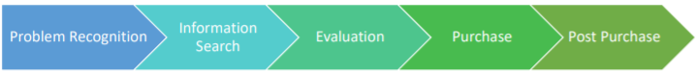

Problem recognition
- Recognition of the problem or need is triggered by internal or external stimuli
  - Internal stimuli are one’s own ‘normal’ needs e.g. hunger, thirst, sex. These rise to a threshold level and become a drive
  - External stimuli can include observation of others with a new product and advertising of a product, whether formally or through word of mouth

Information search
- After recognising their need, consumers search for limited amounts of information on potential ways to satisfy this need. We distinguish between two levels of engagement in this search:
  - In the heightened attention state, the potential consumer is simply more receptive to information about a product i.e., passively searching
  - At the next level, the active information search, the consumer is looking for reading material, researching online, asking friends’ opinions, visiting stores etc.
- The information sources which the potential consumer has access to can be categorised into personal, commercial, public, and experiential sources.
  - Personal: family, friends, neighbours
  - Commercial: advertising, websites, salespeople, displays
  - Public: mass media, consumer-rating organisations, media hype
  - Experiential: handling, examining and using the product

Evaluation of alternatives
- Product attributes
  - What are the relevant features of this product and its alternatives?
- Degree of importance
  - Weighted average constructed to account for the relative importance of each attribute to that specific consumer
- Product beliefs
  - Consumer perceptions of the performance of alternatives on each attribute
- Consideration set
  - Based on this, which set of alternatives are viable? Smaller than the starting number

Purchase decision
- Having examined the alternatives, the consumer makes their final decisions which include:
  - From whom to buy
  - When to buy

Post-purchase
- After purchasing, the consumer compares the product with their expectations and then either feels satisfied or dissatisfied
  - Can leave reviews expressing this, which have become a central marketing topic
- Deng found an app received worse reviews after a price promotion which made the app free. The hypothesis is that match value is lower for consumers; because its free, consumers will consume even if it is not closely aligned to their needs.
    - People will skip information search stage and alternative evaluation stage.
  - This implies that marketing decisions should not be independent; price decision led to unfavourable customer views, so the firm should think about the long-term consequence of price promotions and how they fit with other marketing decisions
  - Price-quality inference can also lead consumers to value products less after discounts.

Behavioural economics introduction

Bounded rationality
- When consumers make decisions, their rationality is limited by the tractability of the decision problem, their cognitive limitations, and the time available. Decision-makers are satisficers, seeking a satisfactory solution rather than an optimal one
  - Most of what we do is habitual and automatic, using heuristics. People are predictably irrational.
  - If decisionmakers slow down, they are less likely to be influenced by biases

Herding
- Opower example; showing users other people’s energy use influences their own behaviour. Consumers will use less energy when they see information about other people’s usage
  - Effect is bigger when the comparison households are nearer to you

Power of defaults
- Opt in vs opt out organ donation – the effect of default / endowment effects
  - How we design the form is important

Priming
- Priming; an implicit memory effect in which exposure to one stimulus influences the response to another stimulus
  - Ikea low price hotdog advert primes consumers to think all Ikea products are extremely cheap

Prospect theory
- Reference dependence: when evaluating outcomes, the outcome is compared to an expectation or reference point. Outcomes then classified into gains and losses vs this point.
  - Fake black Friday discounting leverage consumer irrationality by creating an artificially high reference point so subsequent price is more attractive.
  - Anchoring
- Loss aversion: outcomes are classified into gains and losses as compared to the reference point, and losses are avoided more than equivalent gains are sought
Marketing is applied microeconomics which recognises cognitive limitations and market imperfections. Seeks to satisfy those needs by implementing a 4 Ps marketing programme

Judgement under Uncertainty (Tversky and Kahneman)

Representativeness
This is where people predict by selecting the outcome (for example, an occupation) that is most representative of the input (for example, the description of a person). Subject to a number of biases:
- Insensitivity to prior probabilities
- Insensitivity to predictability; if people predict solely in terms of the favourableness with which we describe an opportunity, their predictions will be insensitivity to the reliability of evidence and expected accuracy of this prediction
- Illusion of validity; people have unwarranted confidence produced by a good fit between the predicted outcome and the input information

Availability of instances
Biases due to the retrievability of instances; when the size of a class is judged by the availability of its instances, a class whose instances are easily retrievable will seem more numerous than a class of identical frequency whose instances are less retrievable
- In lists where the men were relatively more famous than the women, subjects judged the male class as larger even if they were identical

Adjustment and anchoring
In many situations, people make estimates by starting from an initial value that is adjusted to yield the final answer. Adjustments are usually insufficient; the new estimates are biased toward the initial values. This is anchoring.
- Insufficient adjustment occurs both when the starting point is given to the subject and when the subject finds his starting point based on incomplete computation.
- Conjunctive and disjunctive events. People tend to overestimate the probability of conjunctive events due to anchoring. This can lead to unwarranted optimism, i.e., when evaluating the likelihood that a project will be completed on time:
  - Multiple stages must be successful. Each has a high chance of success, and subjects fail to adequately adjust from this when accounting for the overall probability of success.
  - Anchoring leads to underestimation of the risk of failure in complex systems

Importance of anchoring effects
- Affects decision-making under uncertainty through assessment of probabilities. Confidence intervals too narrow, adjustment from mean not enough
- Affects estimation of willingness to pay in bargaining. Your first offer becomes an anchor, then other consumers make adjustments, so overall willingness to pay will be higher than without the anchor. This is empirically true for houses.
- Also, transactions, auctions, sales pricing

Allais Paradox
- A certainty effect: when a certain outcome is available, it enhances risk aversion. When presented with two options, one certain one uncertain, consumers may choose the option with a lower expected return because certainty is preferred.
Framing effects can lead to inconsistent consumer preferences. Role of marketing here? Positive vs negative framing

Consumer behaviour and policy (Reisch and Zhao, 2016)
- From homo economicus to homo consumers – individuals are not rational, utility-maximising agents. They are subject to systemic biases and heuristics, strongly dependant on the decision’s context. Paper examines the impacts of key principles on consumer’s decisions.

Insights from behavioural economics
- How we can improve consumer welfare is focused on decision heuristics and biases, as well as the specific effect of the situation, or the decision context (Thaler, 2008). We have long understood bounded rationality (Simon, 1956), which can lead consumers to compromise their own interests (Luth, 2010).
- Traditional view of the sovereign consumer is that consumer behaviour is largely determined by preferences (based on information provided), incomes and prices (Brennan, 2014), and that human biases are generally “irrelevant”, not systemic (Reisch, 2015)

Consumer behaviour and behavioural economics
- Status quo biases. Deviation from the status quo is generally considered a loss. Simultaneously, due to endowment effects leading to loss aversion, consumers prefer maintaining the current state.
  - Carroll (2009): status quo effects in organ donation programmes
  - Johnson (2003): higher tipping defaults leads to higher average tips
  - Even disclosing status quo biases does not reduce its effect (Steffel, 2016)
- Endowment effect is also caused by consumers’ asymmetric responses to losses versus gains. This is an inclination to value more highly an item in one’s own possession than items one does not yet down (Thaler, 1980).
  - WTP for a mug is significantly higher amongst people who already own it vs those who do not own it (Kahnemann, 1991)
  - Effects also observed for pens, candy, basketball tickets (Ariely, 2008)
  - Even perceived ownership can lead to the endowment effect e.g., consumers merely touching a screen to learn about a product vs using a mouse (Brasel, 2014)
- Mental accounting is a type of cognitive bookkeeping used to control consumption (Thaler)
  - Earmarking is where consumer assign expenses into different categories e.g., food, and constrain spending based on the budget pre-assigned to each category.
  - This reduces perceived pain of payment and thus increases the consumption enjoyment of products already assigned to a category (Prelec, 1998)
  - Similar earmarking effects apply to saving (Soman, 2011)
- Sunk-cost effect fallacy refers to irrational behaviour to recover already incurred expenditure (Thaler, 1985). Ubiquitous in consumer decisions.
  - People will ski on a rainy day due to prepaid lift ticket (Arkes, 1999)
  - Magnitude depends on temporal gap between payment and consumption (Soman, 2001), with more recent payments incurring a higher sunk cost effect.
- Salience heuristics. Salient information is more attention-grabbing and plays an important role in consumers’ decisions (Tversky, 1974).
  - Placing healthier food options in ore visible and salient positions (Bucher, 2016), or highlighting an unhealthy label (Shah, 2014).
- Anchoring effects whereby people anchor their estimates to an often arbitrary reference value such as a random number generated by a wheel (Tversky, 1974).
  - Can be used in suggested
- Power of simplicity
- Contextual factors

Behaviourally informed consumer policy

Modelling the Psychology of Consumer and Firm Behaviour with Behavioural Economics (Ho et al, 2016)
- Marketing is an applied science which explains how firms and consumers behave in markets. Models apply behavioural economics theories to explore the implications of the limits of rationality. The article explores behavioural economics models which are used in marketing.
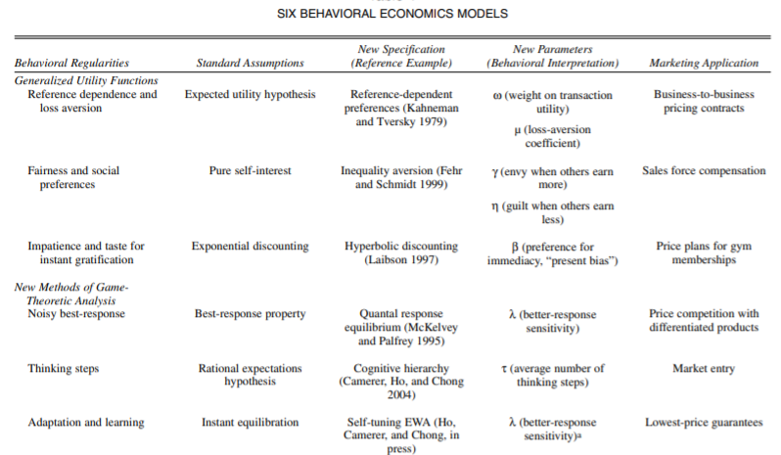
  - Desirable models should have generality, precision, empirical accuracy and psychological plausibility

Reference dependence and loss aversion
- In classical utility theory, the attractiveness of a choice alternative depends only on the final outcome resulting from that choice. However, most judgements are sensitive to points of reference, which suggests changes in outcomes matter, as well as the outcomes themselves.
  - When the point of reference against which an outcome is compared is changed, people’s choices are sensitive to changes in this framing.
- Instant endowment effects for goods demonstrates reference dependence and loss aversion. Effect attributed to a disproportionate aversion to losing an endowment compared with the value of gaining one.
  - Endowing a person with an object shifts their reference point to a state of ownership, and the difference in valuations demonstrates that the disutility of losing a mug is greater than the utility of gaining it.
- Asymmetric price elasticities for price increases and decreases are the main domain of interest to marketers. These are a product of reference dependence and loss aversion.
  - Elasticities are larger for price increases than decreases, meaning demand falls more, relatively, when prices go up than it increases when prices go down.
- Reference dependence in distribution channel pricing (Ho and Zhang, 2004)

Social preferences and fairness
- Classical assumption of pure self-interest, but decision-makers care about fairness + equality
  - Willing to give up money to achieve more equal outcomes / punish others for actions perceived as selfish
  - Utility therefore defined as a function of one’s own payoff and other’s payoffs
- Preference for fairness demonstrated in an “ultimatum” price-posting game.
  - WTP of £1, monopolist makes an offer to consumer, if consumer rejects, they both receive 0 utility
  - Self-interest would dictate an offer of £0.99 but in reality it tends to £0.65 due to the social preferences customers have, which would cause them to sacrifice their payoff to punish an unfair price.
- Marketing application of this is sales force compensation – how should a manager structure compensation for a salesperson?

Hyperbolic discounting
- Discounted-utility framework assumes decisionmakers make current choices which maximise the discounted sum of utilities in future periods. However, hyperbolic discounting states that agents are relatively farsighted when making trade-offs between rewards at different points in the future, but pursue immediate gratification when it is available.
  - Consequence: behaviour of decisionmakers is not time consistent e.g. they may not make the same decision they expected they would when the actual time period arrives.
- Marketing application example: gym membership price plans. Hyperbolic discounting most likely found for products that involve immediate costs with delayed benefits (gym) or immediate benefits with delayed costs (credit cards). Vigna and Malmendier (2004).

